**Software Requirements**

**Specification**

**for**

**Online Shopping Portal and Product Recommendation**

**Version 1.0 approved**

**Prepared by :**

1. **Bishoy abdmariam**
2. **Ahmed Ibrahim**
3. **Ayman osama**
4. **Rodina sameh**
5. **Gerges nafeh**

**Faculty of computer Science and Artificial intelligence Helwan universty**

**<date created:**

**20\5\2021**

***Copyright © 1999 by Karl E. Wiegers. Permission is granted to use, modify, and distribute this document.***

# Table of Contents

Table of Contents ii

Revision History ii

1. Introduction 1
   1. Purpose 1
   2. Document Conventions 1
   3. Intended Audience and Reading Suggestions 1
   4. Product Scope 1
   5. References 1
2. Overall Description 2
   1. Product Perspective 2
   2. Product Functions 2
   3. User Classes and Characteristics 2
   4. Operating Environment 2
   5. Design and Implementation Constraints 2
   6. User Documentation 2
   7. Assumptions and Dependencies 3
3. External Interface Requirements 3
   1. User Interfaces 3
   2. Hardware Interfaces 3
   3. Software Interfaces 3
   4. Communications Interfaces 3
4. System Features 4
   1. System Feature 1 4
   2. System Feature 2 (and so on) 4
5. Other Nonfunctional Requirements 4
   1. Performance Requirements 4
   2. Safety Requirements 5
   3. Security Requirements 5
   4. Software Quality Attributes 5
   5. Business Rules 5
6. Other Requirements 5

Appendix A: Glossary 5

Appendix B: Analysis Models 5

Appendix C: To Be Determined List 6

# Revision History

|  |  |  |  |
| --- | --- | --- | --- |
| **Name** | **Date** | **Reason For Changes** | **Version** |
|  |  |  |  |
|  |  |  |  |

# Introduction

## Purpose

The main purpose of this project is to help the user to easily search for herbs and fruits that will be good for the health of the user depending on any health issue or disease and This system helps the user to reduce its searching time to a great extent by allowing the user to enter its health problem and search accordingly .

## Document Conventions

No special font or highlighting have special significant in this Srs

## Intended Audience and Reading Suggestions

<Describe the different types of reader that the document is intended for, such as developers, project managers, marketing staff, users, testers, and documentation writers. Describe what the rest of this SRS contains and how it is organized. Suggest a sequence for reading the document, beginning with the overview sections and proceeding through the sections that are most pertinent to each reader type.>

## Product Scope

Auction System is specific to whom search for fruits and herbs online and who had products aim to be sold with highest benefits to each one

* User
* admin

## References

* Software engineering course Helwan university

# Overall Description

## Product Perspective

<Describe the context and origin of the product being specified in this SRS. For example, state whether this product is a follow-on member of a product family, a replacement for certain existing systems, or a new, self-contained product. If the SRS defines a component of a larger system, relate the requirements of the larger system to the functionality of this software and identify interfaces between the two. A simple diagram that shows the major components of the overall system, subsystem interconnections, and external interfaces can be helpful.>

## Use case diagram

**Show the** interaction with users which admin can add or delete fruits , herbs and hospitals and user can register , edit profile and search product

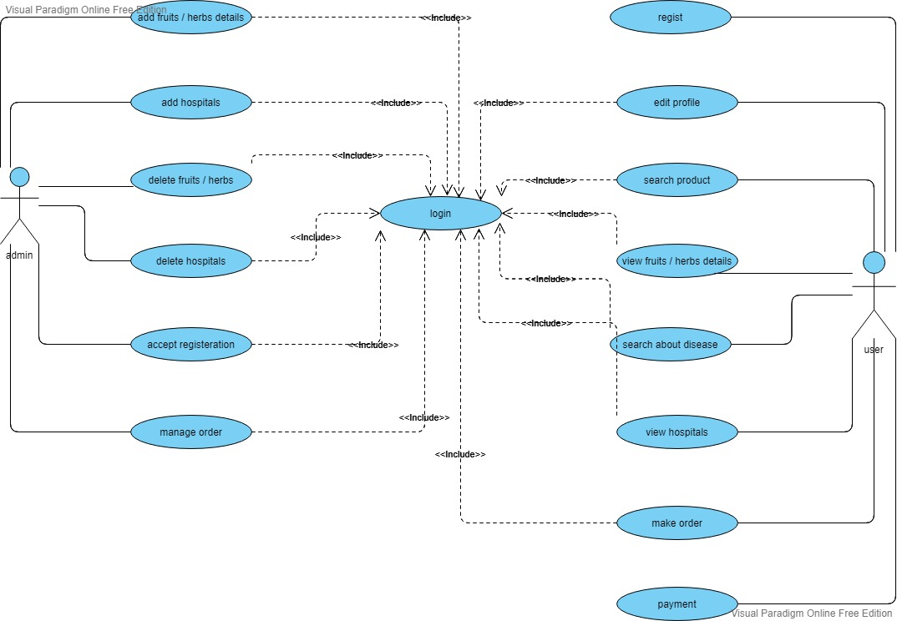

## Use case description

Identifier : add fruits or herbs details

Initiator : admin

Pre condition : admin already has an account on database

Post condition : the fruit or herb has added to list

Main success scenario :

1 : admin logs in with his account

2 :admin adds a new fruit or herb to the list

3 : the fruit or herb has added to the list

Goal : adding fruits or herbs

#############################################

Identifier : add hospital

Initiator : admin

Pre condition : admin already has an account

Post condition : a new hospital has been added

Main success scenario :

1 : admin logs in with his account

2 : admin adds a new hospital to the list

3 : new hospital has been added to the list

Goal : adding a new hospital

################################################

Identifier : delete fruits or herbs details

Initiator : admin

Pre condition : admin already has an account

Post condition : the fruit or herb has deleted from list

Main success scenario :

1 : admin logs in with his account

2 :admin deletes an old fruit or herb from the list

3 : the fruit or herb has been deleted from the list

Goal : deleting fruits or herbs

###################################################

Identifier : delete hospital

Initiator : admin

Pre condition : admin already has an account

Post condition : a hospital has been deleted

Main success scenario :

1 : admin logs in with his account

2 : admin deletes a hospital from the list

3 : hospital has been deleted from the list

Goal : deleting a hospital

################################################

Identifier : accept registration

Initiator : admin

Pre condition : admin already has an account and registration has been requested to be approved

Post condition : an account has been approved and being able to use system

Main success scenario :

1 : admin logs in with his account

2 : admin approved the registration from the user

3 : an account has been activated

Goal : accepting registration

#################################################

Identifier : manage order

Initiator : admin

Pre condition : admin already has an account and order has been requested

Post condition : the order is already managed and able to be send to the user

Main success scenario :

1 : admin logs in with his account

2 : admin approved the registration from the user

3 : order is ready to be sent to the user

Goal : managing order

###########################################################

Identifier : register

Initiator : user

Pre condition : none

Post condition : request of registration sends to the admin

Main success scenario :

1 : user opens website

2 : user fills the registration

3 : the registration sent to the admin

4 : admin approves the registration

Goal : user registers for an account

##########################################

Identifier : edit profile

Initiator : user

Pre condition : the user already has an approved account

Post condition : profile has been edited and ready to use

Main success scenario :

1 : user opens website

2 : user opens his account

3 : user edits his own account

4 : account has been edited

Goal : editing an account

############################################

Identifier : search product

Initiator : user

Pre condition : the user already has an approved account

Post condition : view list of products and ready to choose a suitable option

Main success scenario :

1 : user opens website

2 : user logs in with his account

3 : user search about fruits or herbs

4 : list of products have been appeared

Goal : searching products

#####################################################

Identifier : view details from products

Initiator : user

Pre condition : the user already has an approved account and has searched about products

Post condition : view much more details about the product which been searched

Main success scenario :

1 : user opens website

2 : user logs in with his account

3 : user search about fruits or herbs

4 : list of products have been appeared

5 : much more details about the product has been viewed

Goal : viewing details about products

#######################################################

Identifier : search about diseases

Initiator : user

Pre condition : the user already has an approved account

Post condition : list of diseases is ready to show

Main success scenario :

1 : user opens website

2 : user logs in with his account

3 : user search about diseases

4 : list of diseases have been appeared

Goal : viewing list of diseases

#######################################################

Identifier : view hospitals

Initiator : user

Pre condition : the user already has an approved account and searched about hospitals

Post condition : list of hospitals is ready to show and ready to register in hospital

Main success scenario :

1 : user opens website

2 : user logs in with his account

3 : user search about hospitals

4 : list of hospitals have been appeared

5 : system ready for user to register

Goal : viewing list of searched hospitals

######################################################

Identifier : make order

Initiator : user

Pre condition : the user already has an approved account and searched about products and already has way to payment

Post condition : order sent to admin to be approved and performing the payment process

Main success scenario :

1 : user opens website

2 : user logs in with his account

3 : user search about products

4 : list of products have been appeared

5 : user make his own order

6 : the order sent to the admin to be approved

Goal : making order

########################################################

Identifier : payment

Initiator : user

Pre condition : the user already has an approved account and searched about products and already has way to payment and the order has been approved by the admin and the product ready to sent

Post condition : sending the product to the user

Main success scenario :

1 : user opens website

2 : user logs in with his account

3 : user search about products

4 : list of products have been appeared

5 : user make his own order

6 : the order sent to the admin to be approved

7 : pay the bill for the product

Goal : performing the payment process

####################################

## Activity diagram

## User activity diagram

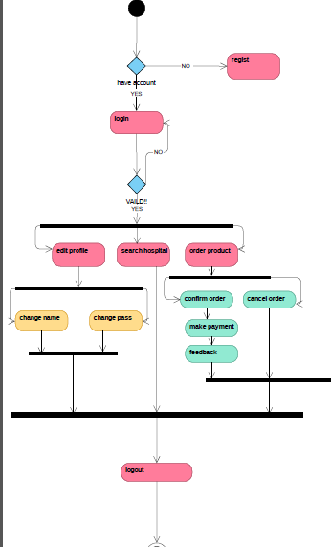

**Admin activity diagram**

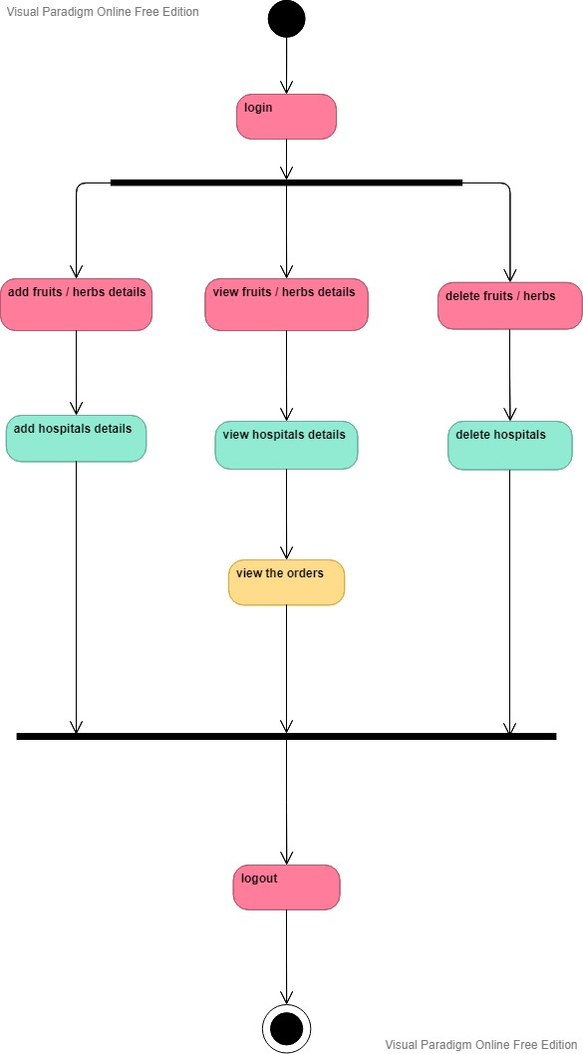

## Design and Implementation Constraints

**User who use this website should have verified account and suitable age**

Front end:

* HTML(hyper text markup language) to set the skeleton of the web site
* Css (cascading style sheet)Styling the website
* javascript

Backend:

* php ,MYSQL

Database:

* mysql database

## User Classes and Characteristics

In this SRS we define seven class

* customer
* user
* admin
* product
* order
* shopping card

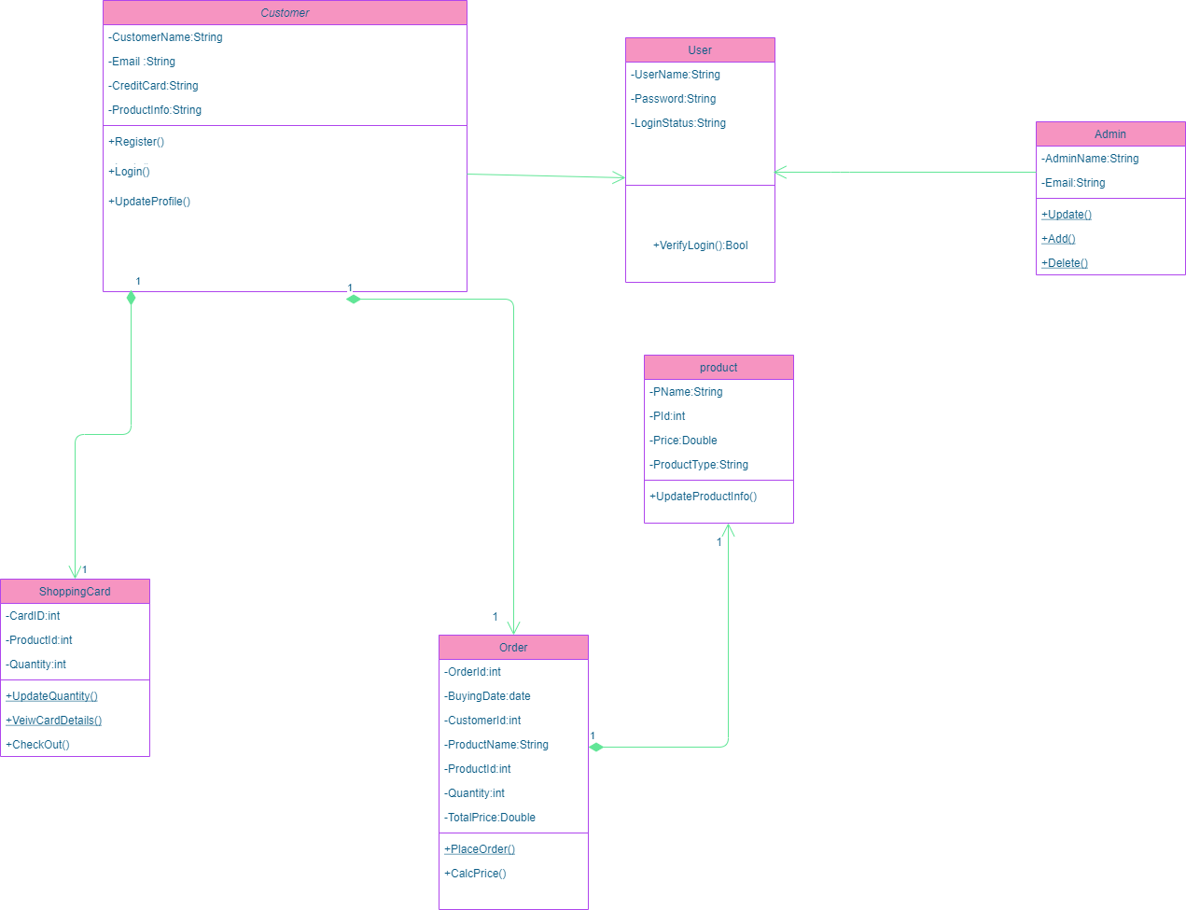

## Database diagram

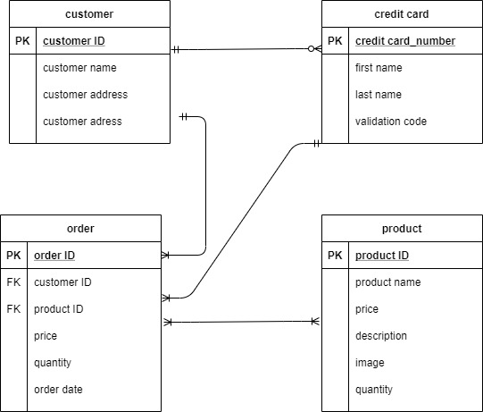

# External Interface Requirements

## User Interfaces

<Describe the logical characteristics of each interface between the software product and the users. This may include sample screen images, any GUI standards or product family style guides that are to be followed, screen layout constraints, standard buttons and functions (e.g., help) that will appear on every screen, keyboard shortcuts, error message display standards, and so on. Define the software components for which a user interface is needed. Details of the user interface design should be documented in a separate user interface specification.>

# System Features

1. ***Functional requirements;***

|  |  |
| --- | --- |
| **Requirment ID** | **Requirment Statment** |
| FR001 | 1-Admin will add and delete and update product . |
| FR002 | 2- Admin will add and delete and update hospital . |
| FR003 | 3-Website shall hava a home page that list purpose of organization . |
| FR004 | 4- Website shall have page called ”OUR CUSTOMER” to make customer send us reviews about product . |
| FR005 | 5-Registered users (customers) can purchase product by using payment methods (Paypal, Credit card, Debit card) . |
| FR006 | 6-Website will allow user to search about product by different filters |
| FR007 | 7-A “Contact Us” page shall provide names and contact information for every person to contact us . |

## System Feature 2 (and so on)

1. **Other Nonfunctional Requirements**

|  |  |
| --- | --- |
| 1-Performance | 1-The system must respond the operation in less than 3 seconds for user.  2- The system should be reliable |
| 2-Safety and Security Requirement | 1-The system must handle safe login and logout.  2- The database should be secured from SQL injection to prevent loss of information.  3- Should handle the secure login for users. |
| 3-Reliabilty | 1-The program should provide catching of exceptions to avoid system crashes or data validation failures. |
| 4-Usability | 1-The system has to be easy to be used. |
| 5-Availability | 1-The system should be available.  2- The system should be with no more than 20 mins down time per day. |